# Compass - Override/PA History

Override/PA History Tab

Override/PA Tab and Override Details Screens

Related Documents

**Description**: Outlines the Override/PA History tab and Override Details screens in Compass.

|  |
| --- |
| **Override/PA History Tab** |

The Override/PA History tab is accessed from the Quick Actions panel at the top of the Claims Landing page.

**Note:** The Expiring Override/PA Flag () is displayed when the Override/PA History tab has a record which will expire in 45 days from the current date. Once the Override/PA History hyperlink is clicked, the flag () is visible on the row that contains the expiring override.

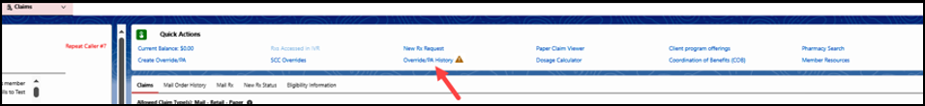

When you click the **Override/PA History** link, the Override/PA History tab will open and display a list of existing Overrides and Prior Authorizations (PAs) on a member’s account in three sections: **Override History**, **PA Status**, and **Initiated ePA**.

**Notes:**

*  Compass will dynamically display the **View Pharmacy/Provider Locks** hyperlink within the Override/PA History tab.
  + This allows agents to view Pharmacy/Provider Locks on a member’s account. For more information, refer to [Compass - Pharmacy/Provider Locks (050038)](https://thesource.cvshealth.com/nuxeo/thesource/#!/view?docid=8c0f0bf6-9b40-482b-8886-ceb43b075f81).
* PA’s may also show under the **Override History Section**.

 Only PA/Overrides for the selected **Carrier/Account/Group** will display. View all coverages to get a full view of these records.

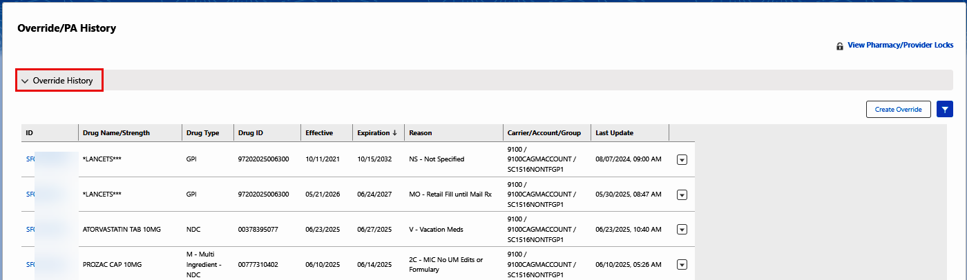

**Click** a hyperlink (from the **ID** column) to view corresponding Override/PA details.

**Notes:**

* If the caller asks whether the PA was sent as an urgent or standard request, click the View Document hyperlink for the appropriate PA. If View Document does not provide the information, call PA department and relay information to the caller. Refer to [Phone Numbers (Contacts, Departments, Directory, Addresses, Hours, and Programs) (004378)](https://thesource.cvshealth.com/nuxeo/thesource/#!/view?docid=f22eb77e-4033-4ad9-9afb-fc262f29faad).
* The **Filter** in each section supports the search of an Override and Prior Authorization.
* Certain **Row Level Actions** ( ) will not show for inactive overrides. **Example:** The action “Duplicate” is hidden for expired or void overrides.

* Select the **Active, Inactive**, or **Both** buttons to view categories.
* Enter the **Drug Name** or **PA ID** to view corresponding details.

* Navigate to the **PA Status** section (expand if needed), and hover over the information **(i)** icon to view the Prior Authorization Turn Around Time Tooltip.

**Note:** Any letter after the PA number identifies this as an appeal. Letters may vary based on specifics of the appeal.

Advise the caller of the standard turnaround times. Only give expedited information if caller states urgent (the PA dept may need to be contacted to verify if the Provider marked it as urgent). Refer to [Phone Numbers (Contacts, Departments, Directory, Addresses, Hours, and Programs) (004378)](https://thesource.cvshealth.com/nuxeo/thesource/#!/view?docid=f22eb77e-4033-4ad9-9afb-fc262f29faad).

Top of the Document

|  |
| --- |
| **Override/PA Tab and Override Details Screens** |

Once you select an **Override ID** hyperlink, the Override Details for that specific override will display. Refer to the following table for additional information about the **Override/PA** tab and Override Details screens.

|  |  |  |  |
| --- | --- | --- | --- |
| **Section/Field** | **Details** | | |
| **Override Details**  (Default View) | Displays **Override Details** information for the specific override, and the **Override/PA** tab is launched.    The following **tabs** display on the left:   * Override Details (default view) * Notes and Attachments * Claims - (Dynamic - displays only if claims are present) * Pharmacy/Provider Locks   The following **accordion sections** display on the left:   * Common Overrides * Requires Special Handling | | |
| **Common Overrides** | Displays commonly used Override flags/information:   * Click the accordion dropdown arrow to open and close. | |
| **Requires Special Handling** | Displays the following **Requires Special Handling** flags/information:   * Click the accordion dropdown arrow to open and close. * Screen defaults to **General.**     The following **buttons** display on the left:   * General (Default) * Range Data * Drug Limitations * Multi Source Code and Formulary * Miscellaneous * Cumulative Refills and Messaging * Provider/Pharmacy Restrictions | |
| **Range Data** | Displays the following information: |
| **Drug Limitations** | Displays the following information:  (For Senior Team Use only) |
| **Multi Source**  **Code and Formulary** | Displays the following information:  (For Senior Team Use only) |
| **Miscellaneous** | Displays the following information:  (For Senior Team Use only) |
| **Cumulative Refills and Messaging** | Displays the following information:  (For Senior Team Use only) |
| **Provider/**  **Pharmacy Restrictions** | Displays the following information:  (For Senior Team Use only) |
| **Notes and Attachments** | Displays a list of existing **Notes and Attachments** for a specific override on member’s account.   * Only enter notes required by the client that are not automatically documented by the system in the **Authorized Notes** field. * Save by clicking the **Save Changes** button, located in the top right corner.      * Hover over the **Information Icon** (i) to view guidance for entering Notes. | | |
| **Claims** | Displays all claims that apply to the override in the table at the bottom of the screen.  **Note:** Tab is dynamic and only displays if claims are present. | | |
| **Pharmacy /Provider Locks** | Displays **Pharmacy / Provider Locks** currently on a member’s account.  **Note:** For more information, refer to [Compass - Pharmacy/Provider Locks (050038)](https://thesource.cvshealth.com/nuxeo/thesource/#!/view?docid=8c0f0bf6-9b40-482b-8886-ceb43b075f81) | | |

Top of the Document

|  |
| --- |
| **Related Documents** |

[Customer Care Abbreviations, Definitions and Terms Index (017428)](https://thesource.cvshealth.com/nuxeo/thesource/#!/view?docid=c1f1028b-e42c-4b4f-a4cf-cc0b42c91606)

**Parent Document:** [CALL 0049 Customer Care Internal and External Call Handling](https://policy.corp.cvscaremark.com/pnp/faces/DocRenderer?documentId=CALL-0049)

Top of the Document

Not to Be Reproduced or Disclosed to Others without Prior Written Approval

**ELECTRONIC DATA = OFFICIAL VERSION / PAPER COPY = INFORMATIONAL ONLY**